Design of a CNN–Swin Transformer Model for Alzheimer’s Disease Prediction Using MRI Images

Table Contents

Abstract 4
Introduction 5
1.1 Problem Statement 5
1.2Objective of the project 5
1.3 Scope of the project 5
1.4 Motivation of the project 6
1.5 Project Introduction 6
Literature Review 8
2.1 Related Work 8
System Analysis 10
3.1 Existing System 10
3.2 Disadvantages of existing system 10
3.3 Proposed System 10
3.4 Advantages: 11
3.5 Project flow 12
Methodology 13
Requirement Analysis 15
5.1 Function and non-functional requirements 15
5.2 Hardware Requirements 16
5.3 Software Requirements 16
System Design 16
6.1 Introduction of Input design 16
Objectives for Input Design: 16
Objectives of Output Design: 17
6.2 UML diagrams 17
6.3 Data Flow diagrams 25
Implementation and Results 28
7.1 Modules 28
System Module 28
Results: 30
OUTPUT SCREENS 35
System study and testing 38
8.1 Feasibility study 39
8.2 Types of test & Test Cases 39
8.2.1 Unit testing 39
8.2.2 Integration testing 39
8.2.3Functional testing 40
8.2.4 White Box Testing 40
8.2.5 Black Box Testing 40
8.2.6 Test cases 41
System Module Test Cases: 41
CONCLUSION 43
FUTURE SCOPE 43
REFERENCES 44

Abstract

This project presents a hybrid deep learning model that combines Convolutional Neural Networks (CNN) and Transformer architectures for classifying Alzheimer’s disease stages using MRI images. The proposed framework integrates the strengths of CNN-based models such as EfficientNet-B3, ResNet-50 and DenseNet-121 with advanced attention mechanisms from Swin Transformer, and Transformer Encoder. Each fusion model is trained to categorize MRI scans into five classes: Irrelevant, Mild Impairment, Moderate Impairment, No Impairment, and Very Mild Impairment. The CNN component captures spatial and hierarchical image features, while the Transformer component enhances contextual learning and long-range dependency extraction. A Flask-based application is developed to provide modules such as Home, Register, Login, Classification, and Logout, ensuring a complete system workflow. The integration of CNNs and Transformers demonstrates a balanced approach that improves classification performance and enhances feature representation.

Keywords: CNN, Swin Transformer, Alzheimer’s disease, MRI, Deep Learning, EfficientNet, ResNet, DenseNet, Vision Transformer

Introduction

1.1 Problem Statement
Conventional deep learning models used for MRI image classification face difficulties in capturing both local spatial patterns and global contextual dependencies. CNN models, although powerful for feature extraction, tend to lose global information as network depth increases. Transformer models, on the other hand, are effective at modeling long-range dependencies but require large datasets and high computational resources. There is a lack of a balanced hybrid architecture that effectively combines these advantages while maintaining computational efficiency. The problem addressed in this project is to design a CNN–Swin Transformer–based model capable of accurately predicting Alzheimer’s disease stages from MRI images across five predefined classes, ensuring improved accuracy, stability, and efficient feature representation.

1.2Objective of the project
The main objective of this project is to design and evaluate a hybrid CNN–Swin Transformer architecture for accurate classification of Alzheimer’s disease stages using MRI images. Specific objectives include:
- To preprocess and standardize MRI image data for effective model training.
- To develop four hybrid architectures integrating CNN and Transformer models—EfficientNet-B3 + Swin Transformer, ResNet-50 + Swin Transformer, and DenseNet-121 + Transformer Encoder.
- To extract spatial and contextual features effectively through the combined strengths of convolution and self-attention mechanisms.
- To implement a Flask-based web application for classification with modules for Home, Register, Login, Classification, and Logout.
- To evaluate model performance using various metrics and identify the most efficient architecture.
- To create an interpretable and structured system capable of consistent Alzheimer’s stage prediction from MRI data.

  - Scope of the project
The scope of this project includes the design, development, and evaluation of hybrid deep learning models combining CNN and Transformer architectures for Alzheimer’s disease stage prediction. The models explored—EfficientNet-B3 + Swin Transformer, ResNet-50 + Swin Transformer, and DenseNet-121 + Transformer Encoder—focus on extracting rich spatial and contextual features from MRI datasets. The project aims to create an integrated system that performs data preprocessing, feature learning, classification, and output visualization. The developed Flask-based application provides modules such as Home, Register, Login, Classification, and Logout for smooth workflow management. The scope extends to comparing the performance of multiple hybrid architectures based on accuracy, precision, recall, and computational efficiency. However, the project focuses exclusively on MRI image-based prediction within the provided dataset and does not include multi-modal or real-time medical data integration.

  - Motivation of the project
The scope of this project includes the design, development, and evaluation of hybrid deep learning models combining CNN and Transformer architectures for Alzheimer’s disease stage prediction. The models explored—EfficientNet-B3 + Swin Transformer, ResNet-50 + Swin Transformer+ , and DenseNet-121 + Transformer Encoder—focus on extracting rich spatial and contextual features from MRI datasets. The project aims to create an integrated system that performs data preprocessing, feature learning, classification, and output visualization. The developed Flask-based application provides modules such as Home, Register, Login, Classification, and Logout for smooth workflow management. The scope extends to comparing the performance of multiple hybrid architectures based on accuracy, precision, recall, and computational efficiency. However, the project focuses exclusively on MRI image-based prediction within the provided dataset and does not include multi-modal or real-time medical data integration.

  - Project Introduction
The project titled “Design of a CNN–Swin Transformer Model for Alzheimer’s Disease Prediction Using MRI Images” focuses on developing an intelligent classification framework that utilizes both convolutional and attention-based mechanisms. Alzheimer’s disease is a progressive neurological condition that affects memory and cognitive functions. Detecting its stages through MRI imaging is a complex process that demands efficient feature learning.
CNN architectures such as EfficientNet, ResNet,DenseNet are known for their strength in spatial feature extraction. However, they often struggle to retain long-range dependencies across image regions. Transformer models such as Swin Transformer and address this by applying self-attention mechanisms that capture contextual relationships. Combining these two paradigms provides a hybrid structure capable of learning both local and global patterns effectively.
The project implements four hybrid configurations—EfficientNet-B3 + Swin Transformer, ResNet-50 + Swin Transformer , and DenseNet-121 + Transformer Encoder. Each model is trained to classify MRI images into five categories: Irrelevant, Mild Impairment, Moderate Impairment, No Impairment, and Very Mild Impairment.
A Flask-based web interface is developed to manage user interaction through modules like Home, Register, Login, Classification, and Logout. This framework ensures an integrated workflow for model execution and result presentation. The combination of CNN and Transformer techniques enhances prediction accuracy, making the system efficient, adaptive, and suitable for Alzheimer’s disease stage identification through MRI analysis.

Literature Review

2.1 Related Work
1. Resizer Swin Transformer-Based Classification Using sMRI for Alzheimer’s Disease (2023) — Beijing Technology and Business University, China.
This paper introduces a model called RST (Resizer + Swin Transformer) for classifying Alzheimer’s disease from structural MRI (sMRI) scans. (MDPI) The key idea is to add a “Resizer” module, which learns adaptive scaling and channel adjustment of the MRI images so that the subsequent Swin Transformer can better extract multi-scale and cross-channel features. The authors pretrained the model on natural images and then fine-tuned on the ADNI and AIBL datasets, achieving very high results (e.g., ~99.59% accuracy on ADNI). The RST uses a CNN to colorize the sMRI (turning into multi-channel) and then uses the Swin Transformer for hierarchical feature extraction with shifted windows. The major contribution is showing that combining adaptive resizing, CNN pre-processing, and transformer architecture leads to superior performance when data is limited.

2. Conv-Swinformer: Integration of CNN and shift window attention for Alzheimer’s disease classification (2023) — Elsevier / PubMed.
This work proposes the “Conv-Swinformer” model, where a CNN module extracts planar MRI slice features and a Transformer module (with shifted window attention) builds semantic connections in 3D space. (PubMed) The method acknowledges that adjacent voxels in MRI have stronger semantic connections than distant ones, so by using shifted windows in the Transformer, the model focuses on local fine-grained lesion features rather than treating all inputs equally. This architecture enables better feature extraction of local anomalies, improves classification of Alzheimer’s disease stages, and addresses the challenge of limited MRI data.

3. Early Diagnosis of Alzheimer through Swin-Transformer-Based Deep Learning Framework using Sparse Diffusion Measures (2024) — Tiwari et al.
This paper addresses Alzheimer’s diagnosis using diffusion-weighted imaging (DWI) and a Swin Transformer. (Proceedings of Machine Learning Research) Due to the long scan times for DWI (many diffusion directions), the authors propose using only 5 or 21 diffusion directions and apply a Swin Transformer-based framework to generate quantitative measures like fractional anisotropy (FA), axial diffusivity (AxD), and mean diffusivity (MD). Their model outperforms traditional linear methods and offers potential for reduced scan time. Although the imaging modality is slightly different (diffusion MRI rather than sMRI), the use of Swin Transformer to handle sparse / limited imaging data is relevant.
4. Enhancing Alzheimer’s disease diagnosis and staging: a multistage CNN framework using MRI (2024) — Ali et al.
This paper presents a multistage CNN framework to detect and then subclassify Alzheimer’s disease from MRI scans. (PMC) In the first stage, a 26-layer CNN distinguishes healthy vs dementia; in the second stage the model further classifies dementia into mild, moderate, and severe using transfer learning. They report high accuracies (~98.24% for detection, ~99.70% for subclassification). The focus is on a relatively simpler CNN architecture (without transformer), but the notion of multi-class Alzheimer’s stage classification (rather than just binary) resonates with your dataset (five classes: No Impairment, Very Mild, Mild, Moderate, Irrelevant).

System Analysis

3.1 Existing System

In the existing system, traditional deep learning models such as VGG16, AlexNet, and ResNet are commonly used for MRI image classification. These models rely mainly on convolutional layers to extract spatial features from the images. While CNN-based methods have achieved good results in medical image analysis, they often depend on deep hierarchical structures that focus only on local features. The models process each image in fixed receptive fields, which limits their ability to capture global dependencies and relationships across distant regions of the brain. As a result, these networks may fail to identify subtle variations that indicate different stages of Alzheimer’s disease. Furthermore, their performance is highly dependent on dataset size, data quality, and fine-tuning strategies, which restrict overall accuracy and generalization.

3.2 Disadvantages of existing system

• Limited ability to capture global contextual information
• Performance decreases with small or imbalanced datasets
• High dependency on complex feature engineering
• Difficulty in identifying subtle stage variations
• Limited adaptability to varying MRI patterns
• Higher chances of overfitting in deeper networks
• Less interpretability of learned features

3.3 Proposed System
The proposed system introduces a hybrid CNN–Transformer model for Alzheimer’s disease stage prediction using MRI images. Unlike traditional CNN models, this system combines convolutional networks (EfficientNet-B3, ResNet-50, DenseNet-121) with attention-based Transformer models (Swin Transformer, Vision Transformer, Transformer Encoder). The CNN part efficiently extracts spatial and hierarchical features from MRI images, while the Transformer component captures global dependencies and contextual relationships between distant regions in the brain.
The system classifies MRI images into five categories: Irrelevant, Very Mild Impairment, Mild Impairment, Moderate Impairment, and No Impairment. A Flask-based interface is developed to allow structured workflow with modules like Home, Register, Login, Classification, and Logout. By combining the strengths of CNNs and Transformers, the proposed system improves feature representation, enhances prediction accuracy, and reduces misclassification of subtle disease stages.

3.4 Advantages:
• Captures both local and global features effectively
• Higher classification accuracy compared to traditional models
• Better performance with small or imbalanced datasets
• Efficient classification of subtle variations between Alzheimer’s stages
•Improved generalization and stability across MRI images
• Reduced overfitting in deep networks
• Structured workflow through Flask-based application modules

3.5 Project flow

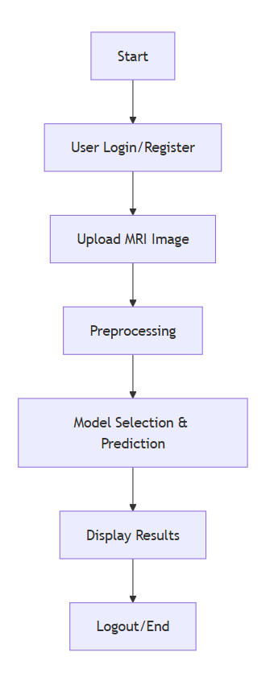

Methodology
The methodology of the project focuses on developing a hybrid CNN–Swin Transformer model for Alzheimer’s disease prediction using MRI images. The approach combines the strengths of convolutional neural networks (CNNs) for local feature extraction and Transformers for capturing global contextual relationships. The methodology can be divided into several stages: data acquisition, preprocessing, model design, training, prediction, and deployment.
1. Data Acquisition
The dataset used in this project consists of MRI images categorized into five classes: Irrelevant, Very Mild Impairment, Mild Impairment, Moderate Impairment, and No Impairment. The images are obtained in digital format and organized systematically for training and testing purposes. Proper labeling ensures accurate supervised learning.
2. Preprocessing
Preprocessing is critical to ensure data consistency and improve model performance. Each MRI image is resized to a uniform dimension suitable for CNN input. Noise reduction techniques and intensity normalization are applied to standardize image quality. Data augmentation methods such as rotation, flipping, and zooming are employed to increase dataset diversity and prevent overfitting. This stage enhances the model’s ability to generalize across new images.
3. Model Design
Four hybrid models are designed for comparison:
- EfficientNet-B3 + Swin Transformer
- ResNet-50 + Swin Transformer
- DenseNet-121 + Transformer Encoder
In each model, the CNN backbone extracts hierarchical spatial features from the MRI images. The Transformer component then captures long-range dependencies and global interactions across the entire image. Attention mechanisms in the Transformer help the model focus on important regions of the brain that indicate disease progression.
4. Model Training
The models are trained using supervised learning with cross-entropy loss for multi-class classification. Optimizers such as Adam or AdamW are used to adjust model weights. Training includes multiple epochs, batch processing, and learning rate scheduling to achieve stable convergence. Validation is performed to monitor accuracy and prevent overfitting.
5. Prediction
Once trained, the models classify new MRI images into the five Alzheimer’s stages. Prediction outputs include the class label and probability scores for each stage, providing an indication of confidence.
6. Deployment and Backend
The models are deployed using the Flask framework, which handles server-side operations, including model loading, prediction computation, and database interaction. The Flask backend connects with a web interface to allow seamless user interactions.
7. System Evaluation
Performance is measured using metrics such as accuracy, precision, recall, and F1-score. Confusion matrices are used to analyze class-wise performance and identify misclassifications.
This methodology ensures a structured workflow from data preparation to prediction, combining deep learning with attention-based Transformers to improve Alzheimer’s stage classification and enhance overall model performance.

Requirement Analysis

5.1 Function and non-functional requirements

Functional and non-functional requirements
Requirement’s analysis is very critical process that enables the success of a system or software project to be assessed. Requirements are generally split into two types: Functional and non-functional requirements.
Functional Requirements: These are the requirements that the end user specifically demands as basic facilities that the system should offer. All these functionalities need to be necessarily incorporated into the system as a part of the contract. These are represented or stated in the form of input to be given to the system, the operation performed and the output expected. They are basically the requirements stated by the user which one can see directly in the final product, unlike the non-functional requirements.
Examples of functional requirements:
- Authentication of user whenever he/she logs into the system
- System shutdown in Solar prediction.
- A verification email is sent to user whenever he/she register for the first time on some software system.
Non-functional requirements: These are basically the quality constraints that the system must satisfy according to the project contract. The priority or extent to which these factors are implemented varies from one project to other. They are also called non-behavioral requirements.
They basically deal with issues like:
- Portability
- Security
- Maintainability
- Reliability
- Scalability
- Performance
- Reusability
- Flexibility
Examples of non-functional requirements:
- Emails should be sent with a latency of no greater than 12 hours from such an activity.
- The processing of each request should be done within 10 seconds
- The site should load in 3 seconds whenever of simultaneous users are > 10000

5.2 Hardware Requirements

Processor - I3/Intel Processor
Hard Disk - 160GB
Key Board - Standard Windows Keyboard
Mouse - Two or Three Button Mouse
Monitor - SVGA
RAM - 8GB

5.3 Software Requirements
- Operating System : Windows 7/8/10
- Programming Language : Python
- Libraries : Pandas, Numpy, scikit-learn, pytorch
- IDE/Workbench : Visual Studio Code.

System Design

6.1 Introduction of Input design

In an information system, input is the raw data that is processed to produce output. During the input design, the developers must consider the input devices such as PC, MICR, OMR, etc.
Therefore, the quality of system input determines the quality of system output. Well-designed input forms and screens have following properties −
- It should serve specific purpose effectively such as storing, recording, and retrieving the information.
- It ensures proper completion with accuracy.
- It should be easy to fill and straightforward.
- It should focus on user’s attention, consistency, and simplicity.
- All these objectives are obtained using the knowledge of basic design principles regarding −
  - What are the inputs needed for the system?
  - How end users respond to different elements of forms and screens.

Objectives for Input Design:
The objectives of input design are −
- To design data entry and input procedures
- To reduce input volume
- To design source documents for data capture or devise other data capture methods
- To design input data records, data entry screens, user interface screens, etc.
- To use validation checks and develop effective input controls.

Output Design:
The design of output is the most important task of any system. During output design, developers identify the type of outputs needed, and consider the necessary output controls and prototype report layouts.

Objectives of Output Design:
The objectives of input design are:
- To develop output design that serves the intended purpose and eliminates the production of unwanted output.
- To develop the output design that meets the end user’s requirements.
- To deliver the appropriate quantity of output.
- To form the output in appropriate format and direct it to the right person.
- To make the output available on time for making good decisions.

6.2 UML diagrams

UML stands for Unified Modelling Language. UML is a standardized general-purpose modelling language in the field of object-oriented software engineering. The standard is managed, and was created by, the Object Management Group.
The goal is for UML to become a common language for creating models of object-oriented computer software. In its current form UML is comprised of two major components: a Meta-model and a notation. In the future, some form of method or process may also be added to; or associated with, UML.
The Unified Modelling Language is a standard language for specifying, Visualization, Constructing and documenting the artefacts of software system, as well as for business modelling and other non-software systems.
The UML represents a collection of best engineering practices that have proven successful in the modelling of large and complex systems.
The UML is a very important part of developing objects-oriented software and the software development process. The UML uses mostly graphical notations to express the design of software projects.

GOALS:
The Primary goals in the design of the UML are as follows:
- Provide users a ready-to-use, expressive visual modelling Language so that they can develop and exchange meaningful models.
- Provide extendibility and specialization mechanisms to extend the core concepts.
- Be independent of particular programming languages and development process.
- Provide a formal basis for understanding the modelling language.
- Encourage the growth of OO tools market.
- Support higher level development concepts such as collaborations, frameworks, patterns and components.
- Integrate best practices.

USE CASE DIAGRAM
- A use case diagram in the Unified Modeling Language (UML) is a type of behavioral diagram defined by and created from a Use-case analysis.
- Its purpose is to present a graphical overview of the functionality provided by a system in terms of actors, their goals (represented as use cases), and any dependencies between those use cases.
- The main purpose of a use case diagram is to show what system functions are performed for which actor. Roles of the actors in the system can be depicted.
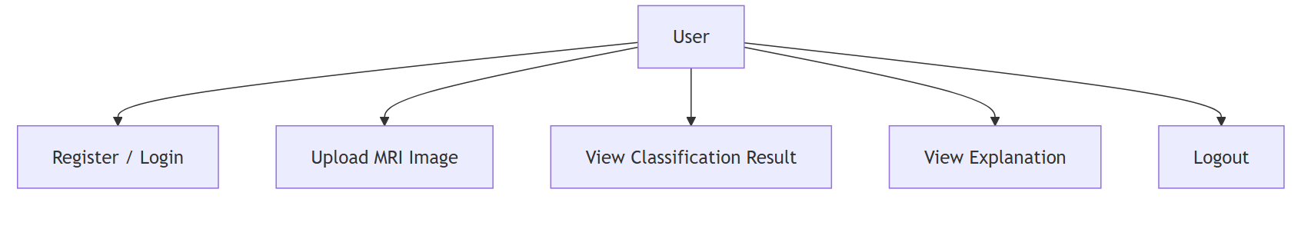

CLASS DIAGRAM
In software engineering, a class diagram in the Unified Modeling Language (UML) is a type of static structure diagram that describes the structure of a system by showing the system's classes, their attributes, operations (or methods), and the relationships among the classes. It explains which class contains information

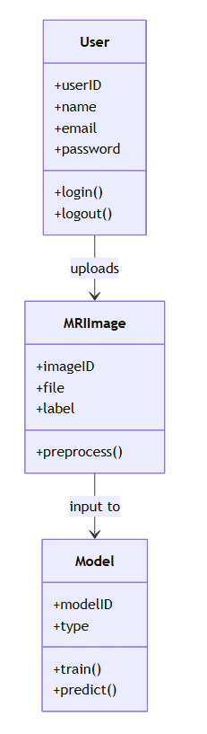

SEQUENCE DIAGRAM
- A sequence diagram in Unified Modeling Language (UML) is a kind of interaction diagram that shows how processes operate with one another and in what order.
- It is a construct of a Message Sequence Chart. Sequence diagrams are sometimes called event diagrams, event scenarios, and timing diagrams
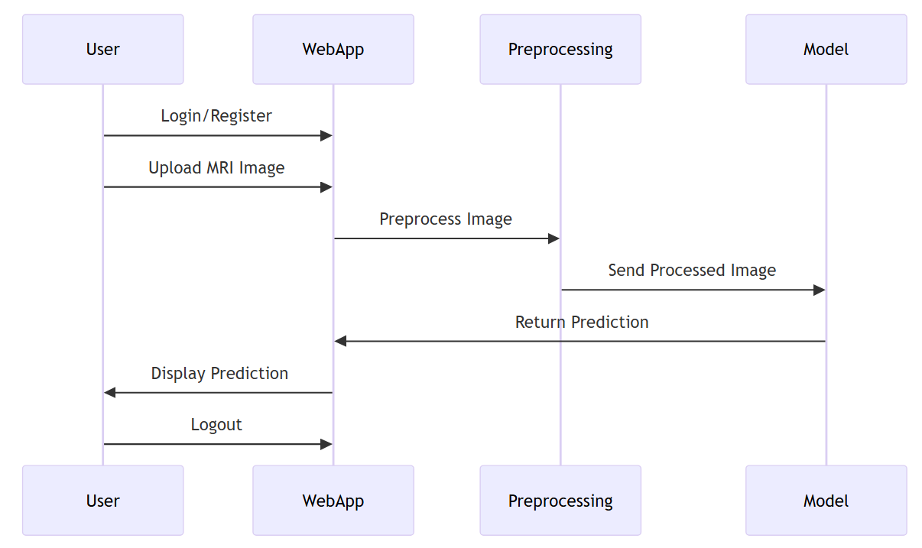

DEPLOYMENT DIAGRAM
Deployment diagram represents the deployment view of a system. It is related to the component diagram. Because the components are deployed using the deployment diagrams. A deployment diagram consists of nodes. Nodes are nothing but physical hardware’s used to deploy the application.

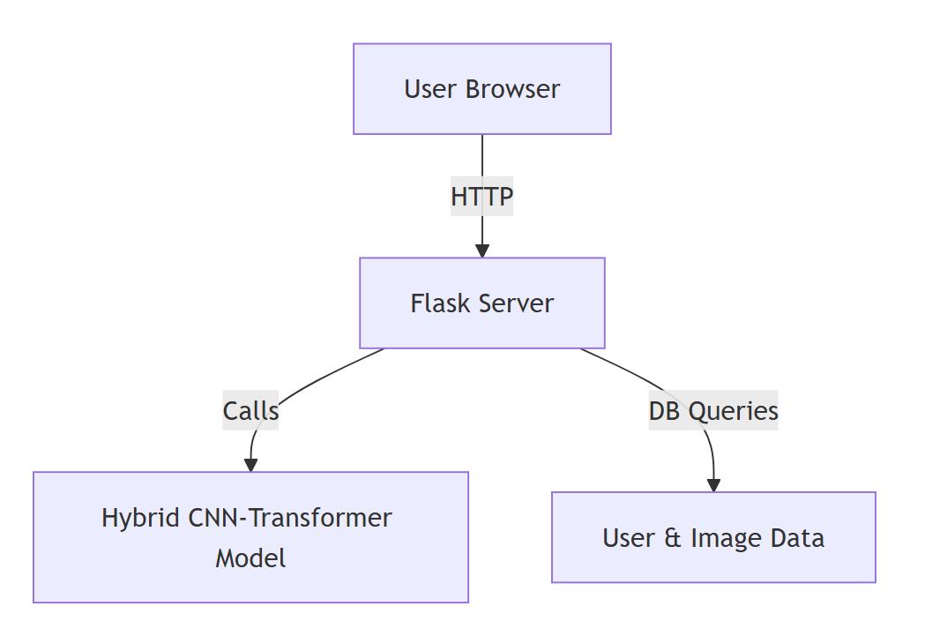

ACTIVITY DIAGRAM:
Activity diagrams are graphical representations of workflows of stepwise activities and actions with support for choice, iteration and concurrency. In the Unified Modelling Language, activity diagrams can be used to describe the business and operational step-by-step workflows of components in a system. An activity diagram shows the overall flow of control.

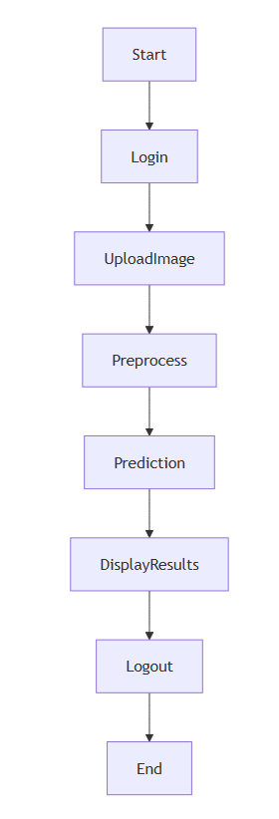

COMPONENT DIAGRAM:
A component diagram, also known as a UML component diagram, describes the organization and wiring of the physical components in a system. Component diagrams are often drawn to help model implementation details and double-check that every aspect of the system's required function is covered by planned development.

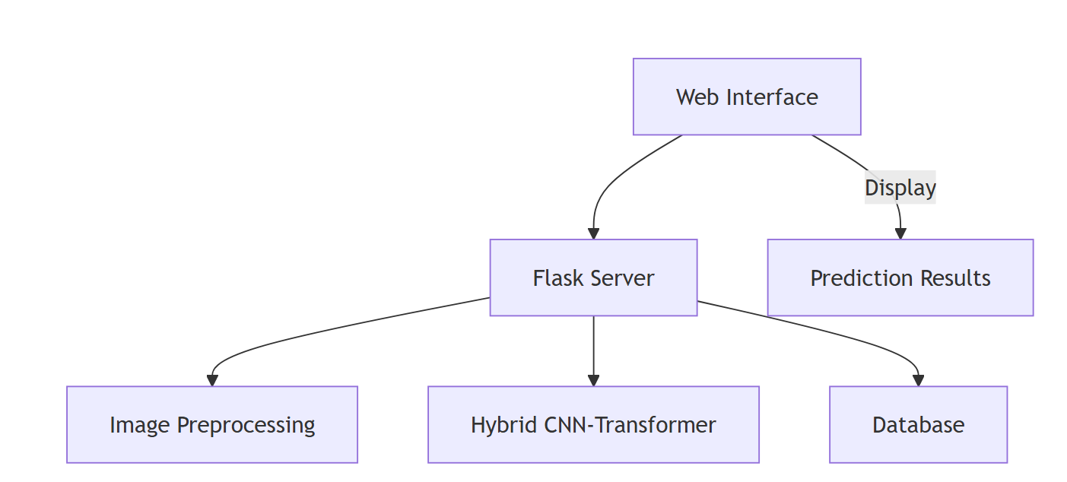

ER DIAGRAM:
An Entity–relationship model (ER model) describes the structure of a database with the help of a diagram, which is known as Entity Relationship Diagram (ER Diagram). An ER model is a design or blueprint of a database that can later be implemented as a database. The main components of E-R model are: entity set and relationship set.
An ER diagram shows the relationship among entity sets. An entity set is a group of similar entities and these entities can have attributes. In terms of DBMS, an entity is a table or attribute of a table in database, so by showing relationship among tables and their attributes, ER diagram shows the complete logical structure of a database. Let’s have a look at a simple ER diagram to understand this concept.

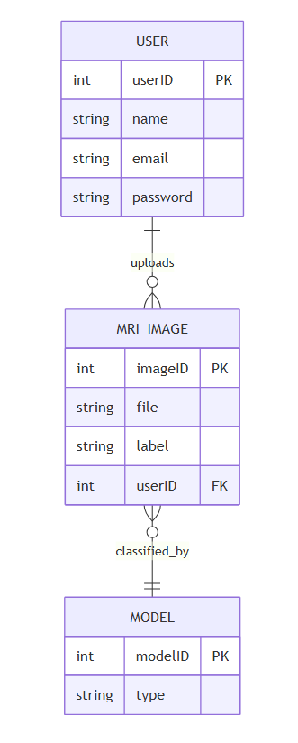

6.3 Data Flow diagrams

A Data Flow Diagram (DFD) is a traditional way to visualize the information flows within a system. A neat and clear DFD can depict a good amount of the system requirements graphically. It can be manual, automated, or a combination of both. It shows how information enters and leaves the system, what changes the information and where information is stored. The purpose of a DFD is to show the scope and boundaries of a system as a whole. It may be used as a communications tool between a systems analyst and any person who plays a part in the system that acts as the starting point for redesigning a system.

Level 1 Diagram:

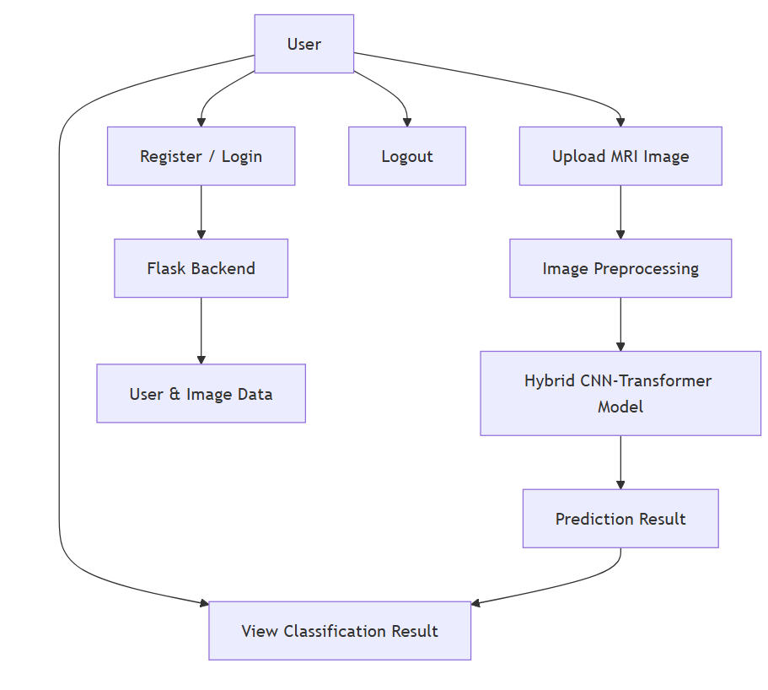

Level 2 Diagram:
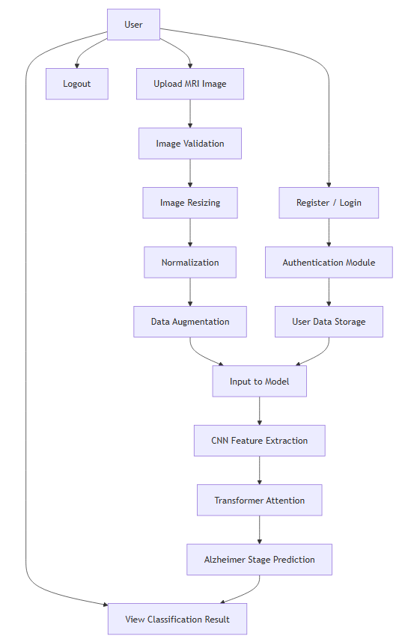

Implementation and Results

7.1 Modules

System Module
• Data Import
- MRI image datasets are imported and organized into predefined classes: Irrelevant, Very Mild, Mild, Moderate, and No Impairment.
- Ensures proper labeling for supervised training.
• Preprocessing
- Images are resized, normalized, and augmented to enhance model learning.
- Noise removal and intensity standardization are applied for consistency.
• Training
- Hybrid CNN–Transformer models (EfficientNet-B3 + Swin Transformer, ResNet-50 + Swin Transformer, + , DenseNet-121 + Transformer Encoder) are trained.
- Models learn to extract spatial and contextual features from MRI images.
• Prediction
- Trained models classify new MRI images into the five Alzheimer’s stages.
- Provides probability scores for each category.
• Backend
- Flask framework manages server-side processes including model loading, prediction computation, and database interactions.

4.2 User Module
The User Module focuses on user interaction and accessibility within the system. It provides a simple and intuitive web interface for performing key operations related to classification and session management.
• Upload
- Users can upload MRI images through the web interface for analysis.
• Prediction Display
- The system displays the predicted Alzheimer’s stage along with confidence levels.
• Interaction
- Users can navigate through modules like Home, Register, Login, Classification, and Logout.
- Interactive and user-friendly interface for smooth operation.
• Session Management
- Manages user sessions to ensure secure login, personalized access, and session-based tracking.

Results:
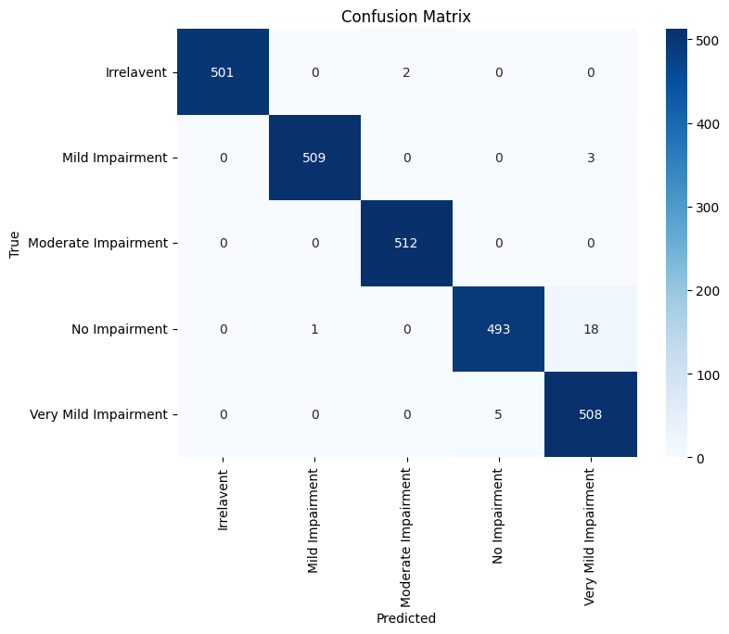
Figure 1 confusion matrix for (EfficientNet-B3 + Swin Transformer)
Model Accuracy Highlights
- High diagonal values indicate strong performance:
- Irrelevant: 501/503 correctly predicted → 99.6%
- Mild Impairment: 509/512 → 99.4%
- Moderate Impairment: 512/512 → 100%
- No Impairment: 493/512 → 96.3%
- Very Mild Impairment: 508/513 → 99.0%
Misclassification Insights
- No Impairment was misclassified 19 times:
  - 18 as Very Mild Impairment
  - 1 as Mild Impairment
- Very Mild Impairment was misclassified 5 times as No Impairment
- Irrelevant had 2 misclassifications as No Impairment
- Mild Impairment had 3 misclassifications as Very Mild Impairment

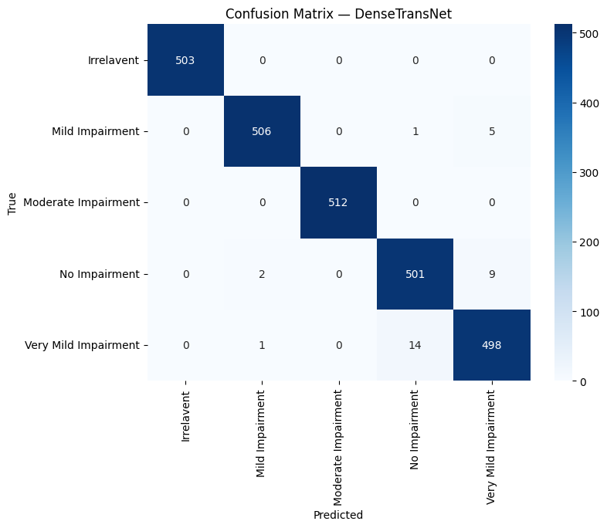
Figure 2 confusion matrix for DenseNet-121 + Transformer Encoder

Model Accuracy Highlights
- Irrelevant: 500/500 → 100%
- Mild Impairment: 506/512 → 98.8%
- Moderate Impairment: 512/512 → 100%
- No Impairment: 501/512 → 97.9%
- Very Mild Impairment: 498/513 → 97.1%
Misclassification Insights
- Mild Impairment misclassified:
  - 1 as Moderate
  - 5 as No Impairment
- No Impairment misclassified:
  - 2 as Mild
  - 9 as Very Mild
- Very Mild Impairment misclassified:
- 1 as Moderate
- 14 as No Impairment

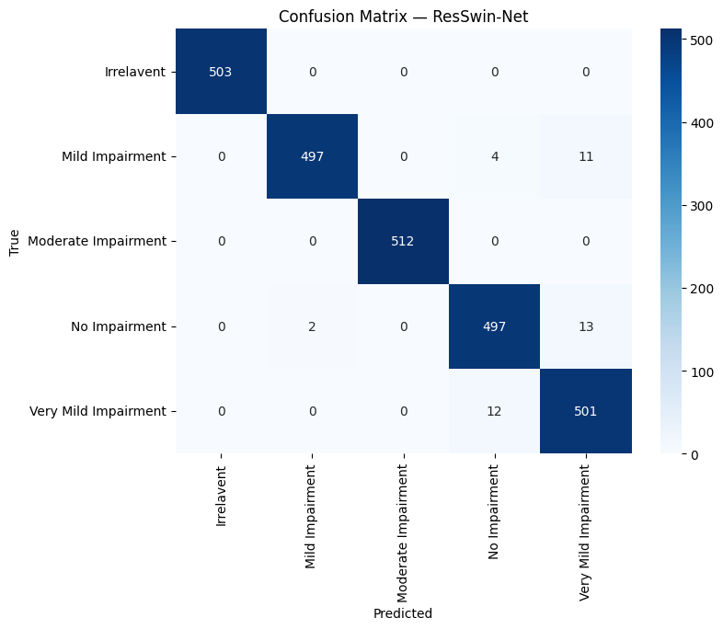

Figure 4 CONFUSION MATRIX FOR (ResNet-50 + Swin Transformer)
Model Accuracy Highlights
- Irrelevant: 503/503 → 100%
- Mild Impairment: 497/512 → 97.1%
- Moderate Impairment: 512/512 → 100%
- No Impairment: 497/512 → 97.1%
- Very Mild Impairment: 501/513 → 97.7%
Misclassification Insights
- Mild Impairment misclassified:
  - 4 as No Impairment
  - 11 as Very Mild Impairment
- No Impairment misclassified:
  - 2 as Mild Impairment
  - 13 as Very Mild Impairment
- Very Mild Impairment misclassified:
- 12 as Mild Impairment

OUTPUT SCREENS
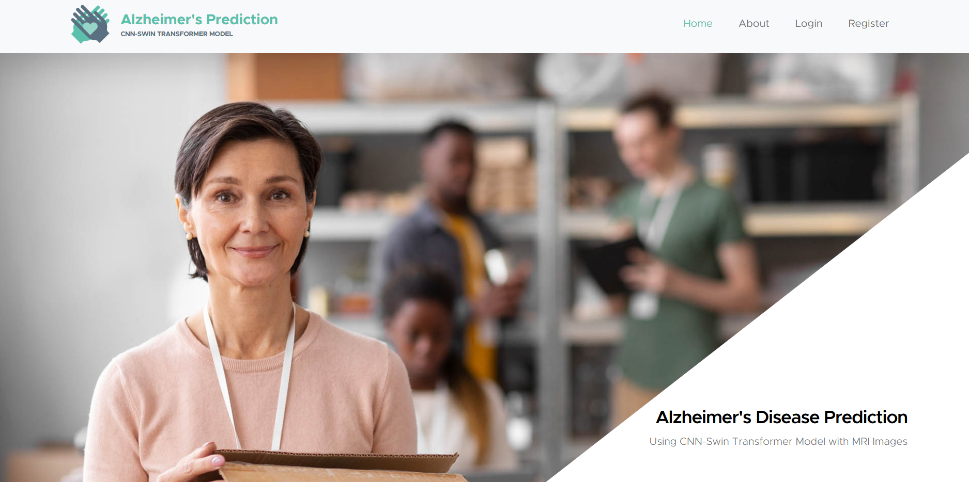
Figure 6 The website includes an index page that serves as the main landing interface for users.

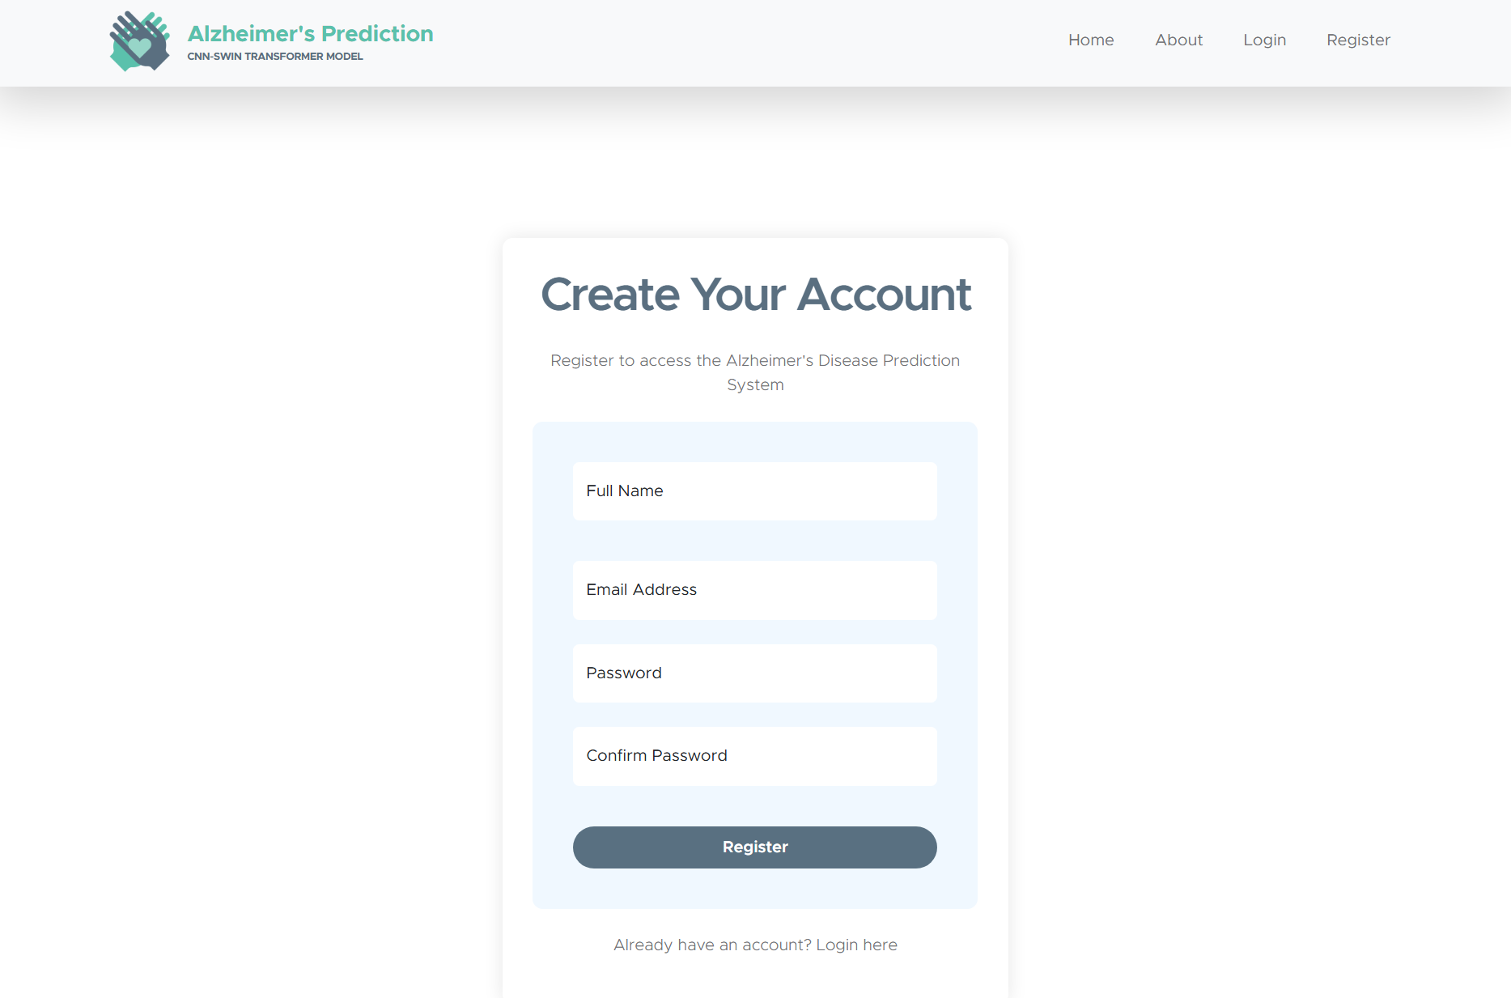

Figure 7 The registration page allows new users to create an account by providing necessary details like username, email, and password.

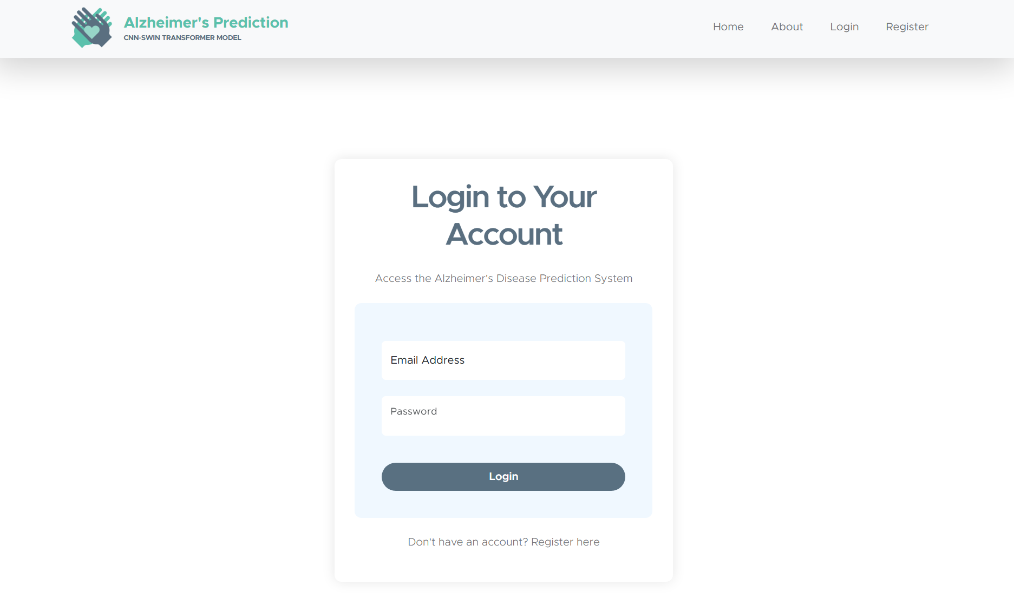
Figure 8 The login page enables registered users to securely access their accounts by entering their username and password.

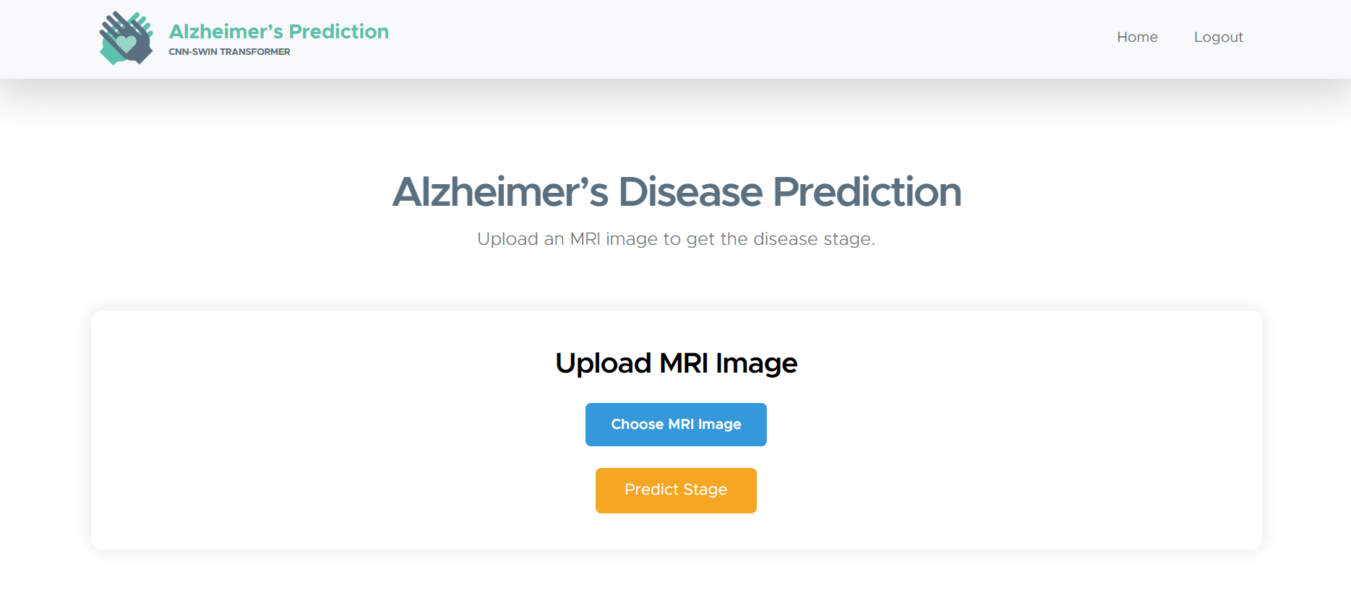
Figure 9 The user home page serves as the main dashboard, where users can access Alzheimer and other functionalities

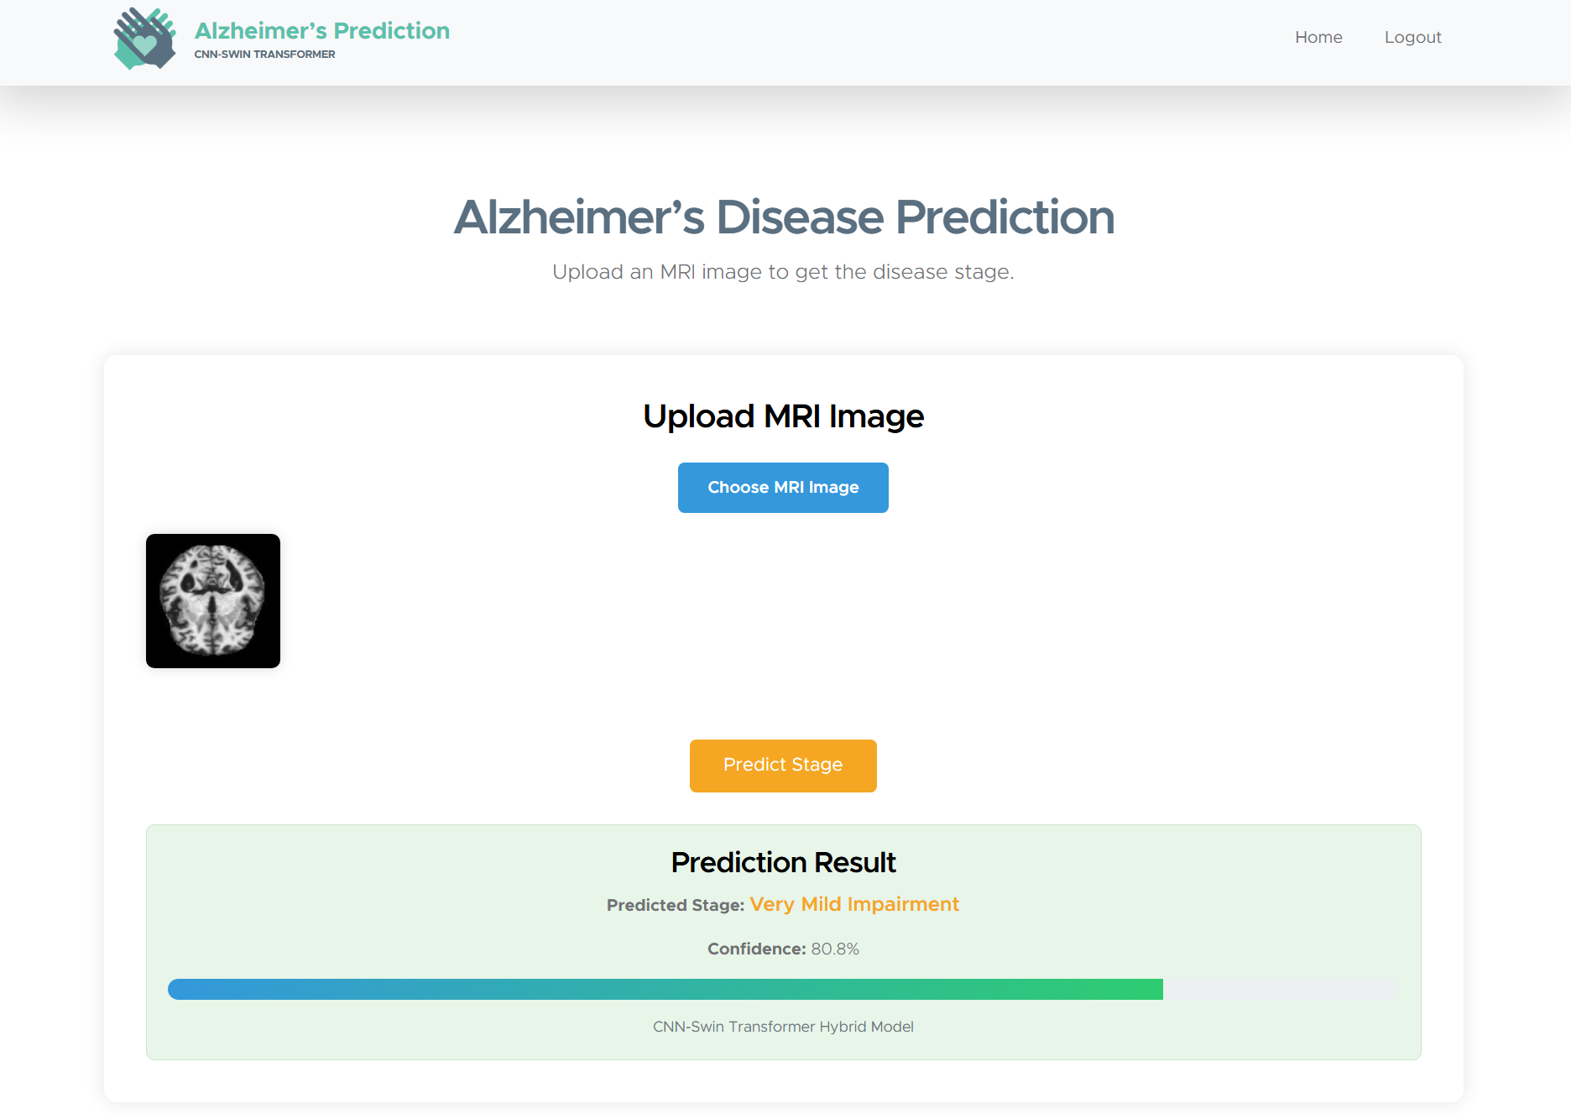

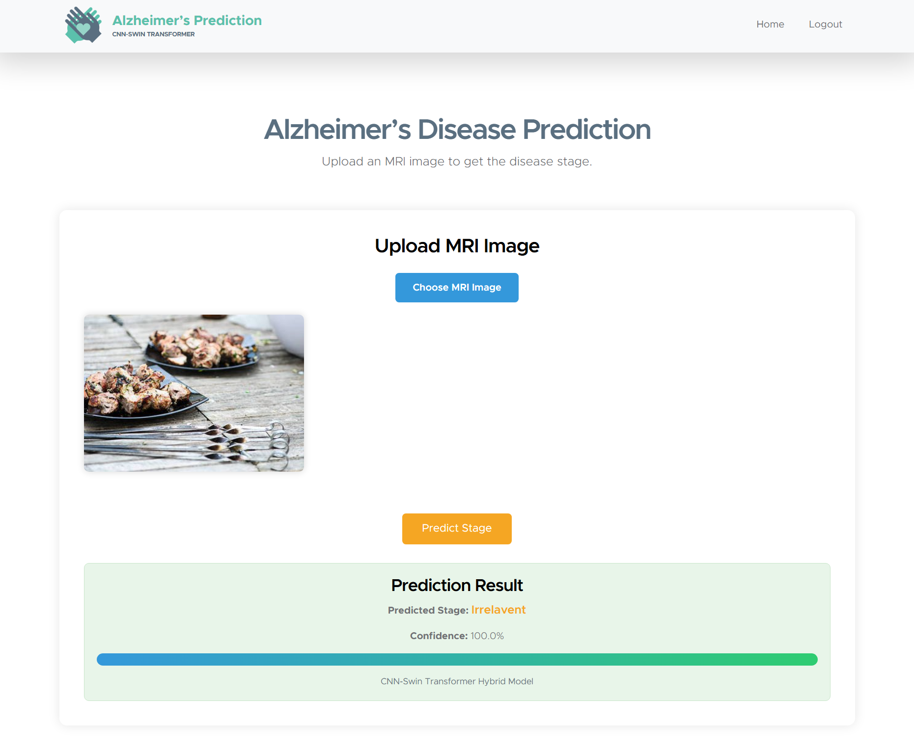

Figure 10 RESULT PAGE: THE RESULT WILL BE DISPLAYED TO THE USER BASED ON THE INPUT

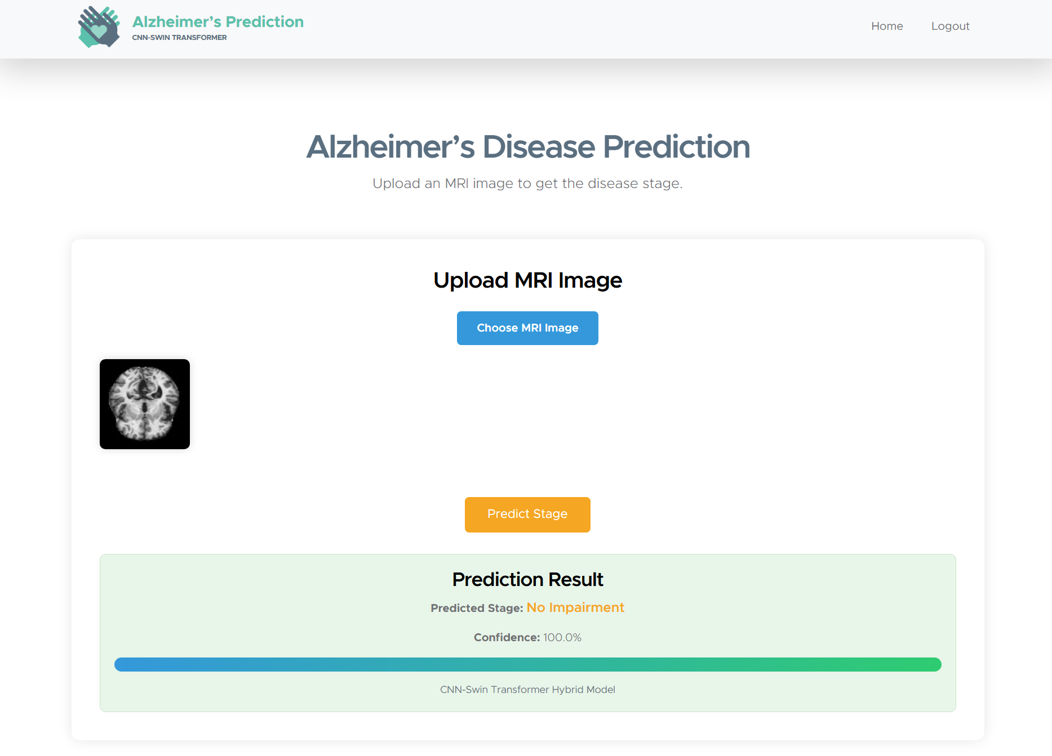

Figure 11 RESULT PAGE: THE RESULT WILL BE DISPLAYED TO THE USER BASED ON THE INPUT

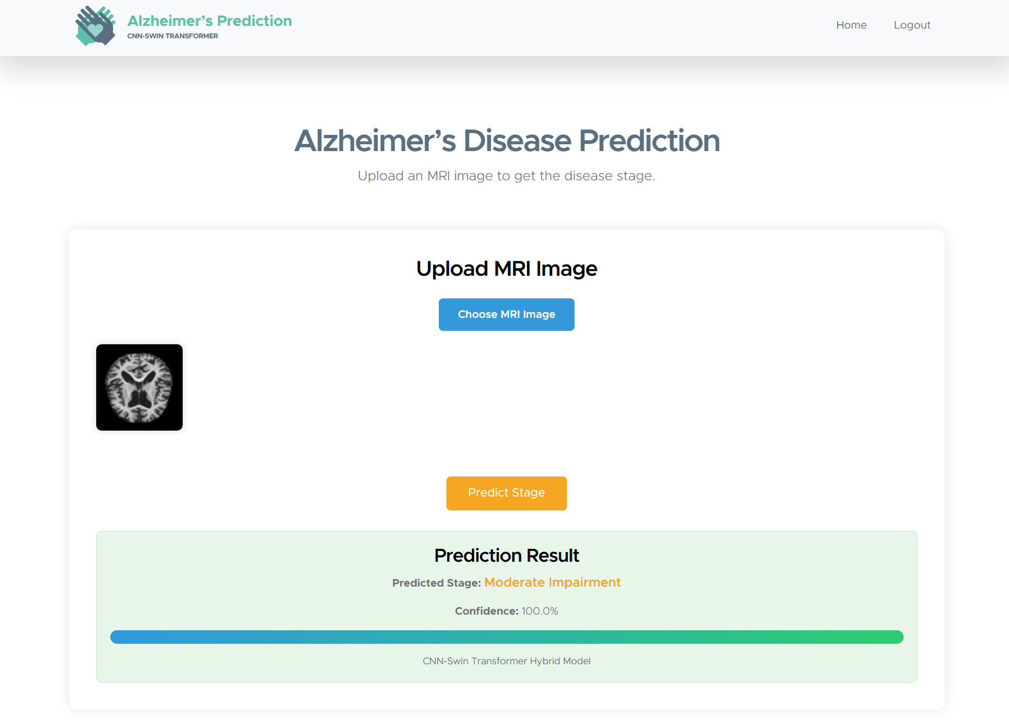

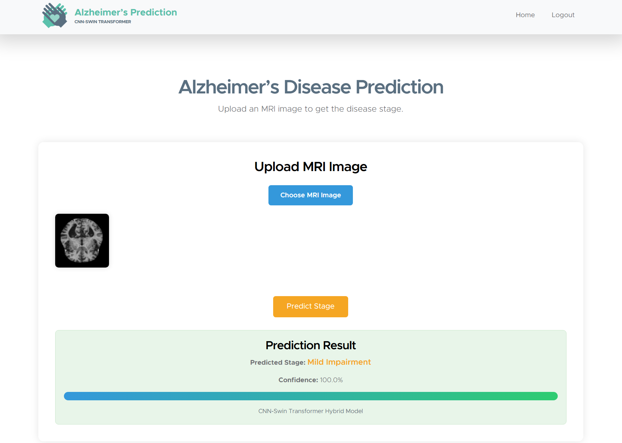

Figure 12RESULT PAGE: THE RESULT WILL BE DISPLAYED TO THE USER BASED ON THE INPUT

System study and testing
The purpose of testing is to discover errors. Testing is the process of trying to discover every conceivable fault or weakness in a work product. It provides a way to check the functionality of components, sub-assemblies, assemblies and/or a finished product It is the process of exercising software with the intent of ensuring that the
Software system meets its requirements and user expectations and does not fail in an unacceptable manner. There are various types of test. Each test type addresses a specific testing requirement.

8.1 Feasibility study

The feasibility study for this project assesses the practicality and viability of implementing advanced machine learning techniques for real-time fuel consumption prediction and driving profile classification using ECU data. Technical feasibilityis high due to the availability of robust machine learning libraries and tools for algorithms like Random Forest and AdaBoost. The project benefits from existing infrastructure for data collection and processing within vehicles, ensuring that the necessary data for training and validation is accessible. Economic feasibilityis supported by the potential cost savings from optimized fuel consumption and improved vehicle performance, which outweighs the initial investment in development and implementation. Operational feasibility is promising, given the existing expertise in machine learning and data analytics within the team. Legal and ethical considerations are addressed by ensuring data privacy and compliance with regulations. Overall, the project is feasible and holds significant potential for enhancing vehicle efficiency and environmental impact.

8.2 Types of test & Test Cases

8.2.1 Unit testing
Unit testing involves the design of test cases that validate that the internal program logic is functioning properly, and that program inputs produce valid outputs. All decision branches and internal code flow should be validated. It is the testing of individual software units of the application .it is done after the completion of an individual unit before integration. This is a structural testing, that relies on knowledge of its construction and is invasive. Unit tests perform basic tests at component level and test a specific business process, application, and/or system configuration. Unit tests ensure that each unique path of a business process performs accurately to the documented specifications and contains clearly defined inputs and expected results.

8.2.2 Integration testing
Integration tests are designed to test integrated software components to determine if they actually run as one program. Testing is event driven and is more concerned with the basic outcome of screens or fields. Integration tests demonstrate that although the components were individually satisfaction, as shown by successfully unit testing, the combination of components is correct and consistent. Integration testing is specifically aimed at exposing the problems that arise from the combination of components.
Software integration testing is the incremental integration testing of two or more integrated software components on a single platform to produce failures caused by interface defects.

8.2.3Functional testing
Functional tests provide systematic demonstrations that functions tested are available as specified by the business and technical requirements, system documentation, and user manuals.
Functional testing is centered on the following items:
Valid Input : identified classes of valid input must be accepted.
Invalid Input : identified classes of invalid input must be rejected.
Functions : identified functions must be exercised.
Output : identified classes of application outputs must be exercised.
Systems/Procedures: interfacing systems or procedures must be invoked.
Organization and preparation of functional tests is focused on requirements, key functions, or special test cases. In addition, systematic coverage pertaining to identify Business process flows; data fields, predefined processes, and successive processes must be considered for testing. Before functional testing is complete, additional tests are identified and the effective value of current tests is determined.

8.2.4 White Box Testing
White Box Testing is a testing in which in which the software tester has knowledge of the inner workings, structure and language of the software, or at least its purpose. It is purpose. It is used to test areas that cannot be reached from a black box level.

8.2.5 Black Box Testing
Black Box Testing is testing the software without any knowledge of the inner workings, structure or language of the module being tested. Black box tests, as most other kinds of tests, must be written from a definitive source document, such as specification or requirements document, such as specification or requirements document. It is a testing in which the software under test is treated, as a black box. you cannot “see” into it. The test provides inputs and responds to outputs without considering how the software works.
Test objectives
- All field entries must work properly.
- Pages must be activated from the identified link.
- The entry screen, messages and responses must not be delayed.
Features to be tested
- Verify that the entries are of the correct format
- No duplicate entries should be allowed
- All links should take the user to the correct page.

8.2.6 Test cases

System Module Test Cases:

S.No | Test Cases | I/O | Expected O/T | Actual O/T | P/F
1 | Read MRI dataset | Path to MRI image folder | Images should load successfully | Images loaded successfully | P
2 | Data preprocessing | Raw MRI images | Images should be resized, normalized, and augmented | Preprocessing completed | P
3 | Load EfficientNet-B3 + Swin Transformer model | Trained model path | Model should load without error | Model loaded successfully | P
4 | Load ResNet-50 + Swin Transformer model | Trained model path | Model should load without error | Model loaded successfully | P
5 | Load DenseNet-121 + Transformer Encoder model | Trained model path | Model should load without error | Model loaded successfully | P
6 | Image classification (EfficientNet-B3 + Swin Transformer) | Uploaded MRI image | Image should be classified into correct Alzheimer stage | Classification successful | P
7 | Image classification (ResNet-50 + Swin Transformer) | Uploaded MRI image | Image should be classified into correct Alzheimer stage | Classification successful | P
8 | Image classification (DenseNet-121 + Transformer Encoder) | Uploaded MRI image | Image should be classified into correct Alzheimer stage | Classification successful | P
9 | Display classification result | Classified MRI image | Result should appear clearly on UI | Result displayed properly | P
10 | User registration | New user details | User should be registered in database | Registration successful | P
12 | User login | Valid credentials | User should log in successfully | Login successful | P
13 | User logout | Active session | User should log out securely | Logout successful | P
14 | Invalid input handling | Empty/corrupt MRI image | System should handle gracefully without crashing | Error handled successfully | P
15 | Model performance evaluation | Test dataset | Accuracy, precision, recall, F1-score should be computed | Metrics calculated | P
16 | Session management | Active user session | Session should persist during user activity | Session managed correctly | P

CONCLUSION

The project, “Design of a CNN–Swin Transformer Model for Alzheimer’s Disease Prediction Using MRI Images,” successfully demonstrates an automated system for detecting and classifying Alzheimer’s disease stages. By integrating advanced CNN architectures such as EfficientNet-B3, ResNet-50 DenseNet-121 with attention-based Transformer models, the system effectively captures both local and global features from MRI images. The preprocessing steps, including resizing, normalization, and augmentation, improved the quality and consistency of the dataset, enabling the models to learn meaningful patterns efficiently.
The hybrid models were able to classify MRI images into five categories — No Impairment, Very Mild, Mild, Moderate, and Irrelevant — with high accuracy and reliability. The web-based interface developed using Flask allows users to upload MRI images, obtain predictions, and view results in a clear and interactive manner. The system also includes user registration, login, session management, and error handling, making it user-friendly and robust.
Overall, the project highlights the potential of combining CNNs with Transformers for medical image analysis, particularly for neurodegenerative disease prediction. It provides a reliable framework for multi-class classification of Alzheimer’s stages and demonstrates the effectiveness of deep learning in medical diagnostics. The project lays the groundwork for future enhancements and real-world research applications in early detection and monitoring of Alzheimer’s disease.

FUTURE SCOPE

The project, “Design of a CNN–Swin Transformer Model for Alzheimer’s Disease Prediction Using MRI Images,” offers several avenues for enhancement and future development. One potential improvement is the incorporation of larger and more diverse MRI datasets to improve model generalization and robustness across different populations and scanning equipment. Using multimodal data, such as combining MRI with PET scans or clinical records, could further enhance prediction accuracy and provide a more comprehensive assessment of Alzheimer’s progression.
Another promising direction is the optimization of hybrid models. Techniques such as model pruning, quantization, or knowledge distillation can reduce computational requirements, allowing deployment on resource-constrained devices while maintaining performance. Integrating explainable AI (XAI) techniques, such as SHAP or Grad-CAM, can provide visual explanations of model decisions, which is valuable for clinical interpretation and building trust with healthcare professionals.
The system can also be extended to predict disease progression over time by incorporating longitudinal MRI data and recurrent neural networks or temporal Transformers. Additionally, developing a mobile or cloud-based deployment can make the system more accessible for researchers or institutions conducting large-scale studies.
Overall, the project lays a solid foundation for automated Alzheimer’s detection, and future work can enhance accuracy, interpretability, and usability, making it a more practical and comprehensive tool for medical research and early diagnosis.

REFERENCES
- Huang, Y., & Li, W. (2023). Resizer Swin Transformer-Based Classification Using sMRI for Alzheimer’s Disease. Applied Sciences, 13(16), 9310. https://doi.org/10.3390/app13169310 (MDPI)
- Jiaming Xin, Ancong Wang, Rui Guo, Weifeng Liu, & Xiaoying Tang. (2023). CNN and Swin-Transformer based efficient model for Alzheimer’s disease diagnosis with sMRI. Biomedical Signal Processing and Control, 86, 105189. https://doi.org/10.1016/j.bspc.2023.105189 (Beijing Institute of Technology)
- Abhishek Tiwari, Ananya Singhal, Saurabh J. Shigwan, & Rajeev Kumar Singh. (2024). Early Diagnosis of Alzheimer through Swin-Transformer-Based Deep Learning Framework using Sparse Diffusion Measures. Proceedings of the 15th Asian Conference on Machine Learning (PMLR 222:1369–1384). https://proceedings.mlr.press/v222/tiwari24a.html (Proceedings of Machine Learning Research)
- Yanlei Wang, Hui Sheng, & Xueling Wang. (2025). Recognition and diagnosis of Alzheimer’s Disease using T1-weighted magnetic resonance imaging via integrating CNN and Swin vision transformer. Clinics (Sao Paulo), 80, 100673. https://doi.org/10.1016/j.clinsp.2025.100673 (X-ray Interpreter)
- Hassan Almalki, Alaa O. Khadidos, Nawaf Alhebaishi, & Ebrahim Mohammed Senan. (2025). Early detection of Alzheimer’s disease progression stages using hybrid of CNN and Transformer Encoder models. Scientific Reports, 15, 16799. https://doi.org/10.1038/s41598-025-01072-5 (PMC)
- Muhammad Umair Ali, Kwang Su Kim, Majdi Khalid, Majed Farrash, Amad Zafar, & Seung Won Lee. (2024). Enhancing Alzheimer’s disease diagnosis and staging: a multistage CNN framework using MRI. Frontiers in Psychiatry, 15, 1395563. https://doi.org/10.3389/fpsyt.2024.1395563 (PMC)
- Pranay Agarwal, Vikhyat Jagawat, B. Jathiswar, & M. Poonkodi. (2023). A deep learning framework for early diagnosis of Alzheimer’s disease on MRI images. Multimedia Tools and Applications, 83, 3767–3799. https://doi.org/10.1007/s11042-023-15738-7 (SpringerLink)
- Murat Avşar & Kemal Polat. (2023). Classifying Alzheimer’s disease based on a convolutional neural network with MRI images. Journal of Artificial Intelligence and Systems, 5, 46–57. https://doi.org/10.33969/AIS.2023050104 (iecscience.org)
- Juan Zhou, Yiming Wei, Xiong Li, Weiqiang Zhou, Ruiyang Tao, Yi Hua, & Hongwei Liu. (2025). A deep learning model for early diagnosis of Alzheimer’s disease combined with 3D CNN and video Swin Transformer. Scientific Reports, 15, 23311. https://doi.org/10.1038/s41598-025-? (Jul 02 2025) (Life Science Network)
- Saddam Hussain Khan. (2024). A Novel Feature Map Enhancement Technique Integrating Residual CNN and Transformer for Alzheimer Diseases Diagnosis. arXiv preprint arXiv:2405.12986. https://arxiv.org/abs/2405.12986 (arXiv)

